Heaven’s Light is Our Guide

Rajshahi University of Engineering & Technology

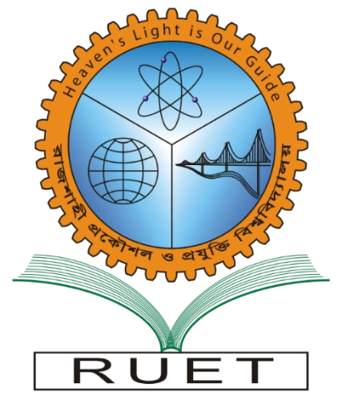
Department of Computer Science and Engineering

Course Code : CSE 4102
Course Title : Compiler Design Sessional

Lab Evaluation Report - 2

Submission Date: December 06, 2025

Submitted By: Submitted To:

Eazdan Mostafa Rafin Farjana Parvin

Roll: 2003055 Assistant Professor
Section : A Dept. of CSE, RUET

